A
MINI PROJECT REPORT ON
PAYROLL PROCESSING APPLICATION
Submitted in partial fulfillment of the requirements for the award of the degree of
MASTER OF COMPUTER APPLICATIONS
BY
B.VENKATA CHAITANYA
(Regd.No:25FFMCA041)
Under the Guidance of
Mrs. P. KAVITHA
(Assistant Professor)

DEPARTMENT OF COMPUTER APPLICATIONS
ANNAMACHARYA UNIVERSITY
NEW BOYANAPALLI-516126, RAJAMPET.

ABSTRACT
A Payroll Processing Application is a software system designed to manage and automate the process of employee salary calculation in an organization. The main objective of this application is to reduce manual work, minimize errors, and ensure accurate and timely payment of salaries. This system maintains employee records, including personal details, salary structure, attendance, and deductions such as taxes, loans, and other contributions. It automatically calculates gross salary, deductions, and net salary based on predefined rules and organizational policies. The application also generates payslips, salary reports, and tax summaries, making it easier for management to track payroll activities.

TABLE OF CONTENTS
1.INTRODUCTION
1.1 Problem definition
1.2 Purpose
1.3 Scope
1.4 Need for system
1.4.1 Existing System
1.4.2 Proposed System
1.5 Architecture
2. SOFTWARE REQUIREMENT SPECIFICATIONS (SRS)
2.1 Introduction to SRS
2.2 User Requirements
2.2.1 Admin (HR) Requirements
2.2.2 Employee Requirements
2.3 Performance Requirements
2.4 Functional Requirements
2.5 Non-Functional Requirements
2.6 Domain Requirements
2.7 Hardware Requirements
2.8 Software Requirements

1.INTRODUCTION
Payroll Processing Application is a system used to manage and calculate employee salaries in an organization. It helps in maintaining employee details and computing salaries based on basic pay, allowances, and deductions.
This system reduces manual work and errors by automating the payroll process. It also ensures accurate and timely salary generation. Overall, it improves efficiency and makes payroll management easier and more reliable.
1.1 PROBLEM DEFINITION
Manual payroll processing is time-consuming and may cause errors in salary calculation. Managing employee records and generating reports is also difficult. Hence, an automated system is needed to ensure accuracy and save time.
Time Consuming Process
Manual payroll processing takes a lot of time, especially when the number of employees is high, making the process slow.
Calculation Errors
There are high chances of mistakes while calculating salaries, allowances, and deductions.
Data Management Issues
Maintaining employee details manually is difficult, and there is a risk of losing records.
Lack of Accuracy
Manual systems may not provide accurate results, especially for complex calculations.
Need for Automation
To overcome all these problems, an automated payroll system is required.

1.2 PURPOSE
The main purpose of the Payroll Processing Application is to automate the process of salary calculation and management in an organization. It helps in maintaining employee records and ensures accurate computation of salaries by considering basic pay, allowances, and deductions.
This system is designed to reduce manual effort, minimize errors, and save time in payroll processing. It also helps in generating salary reports efficiently and maintaining proper records for future reference. Overall, the purpose of this application is to provide a reliable, efficient, and easy-to-use system for managing employee payroll operations.
1.3 SCOPE
The Payroll Processing Application is designed to automate and simplify the salary management process in an organization. It handles employee data, performs salary calculations, and generates reports efficiently. The system mainly focuses on reducing manual work and improving accuracy in payroll operations.
• Managing employee details such as name, ID, and salary information
• Calculating salaries based on basic pay, allowances, and deductions
• Generating payroll reports for employees
• Reducing errors in manual calculations
• Saving time and improving efficiency
• Maintaining records for future reference

1.4 NEED FOR SYSTEM
1.4.1 EXISTING SYSTEM
The existing payroll system is mostly manual, where employee salary, attendance, and deductions are recorded on paper or simple spreadsheets. Calculations are done manually, which takes more time and may lead to errors. It is difficult to manage employee data and generate reports. This system is less efficient and not secure for handling payroll operations.
There is no automatic calculation or report generation. All tasks must be done manually, which reduces productivity.

DISADVANTAGES OF EXISTING SYSTEM
High Initial Cost
Developing and implementing the payroll system requires a high investment.
Maintenance Cost
Regular updates and maintenance are needed, which increases expenses.
Technical Issues
System errors or software bugs may affect payroll processing.
Data Security Risks
Sensitive employee data may be at risk if proper security is not maintained.
Dependency on Technology
The system completely depends on computers and software; failure can stop operations.

1.4.2 PROPOSED SYSTEM
The proposed system is an automated payroll processing application designed to manage employee salary details efficiently. It uses computerized methods to calculate salaries, deductions, bonuses, and taxes accurately. The system stores employee data securely and generates reports quickly, reducing manual work and errors. It improves efficiency, accuracy, and data management in payroll operations.
ADVANTAGES OF PROPOSED SYSTEM
High Accuracy
Automatically calculates salaries, taxes, and deductions with minimal errors.
Time Saving
Processes payroll quickly, reducing manual work and saving time.
Improved Efficiency
Handles large amounts of employee data easily and efficiently.
Data Security
Protects sensitive employee information with secure storage.
Easy Report Generation
Generates payslips, salary reports, and tax details instantly.
Reduced Paperwork
Eliminates the need for manual records and paperwork.
Better Data Management
Stores and organizes employee records in a systematic way.

1.5 ARCHITECTURE
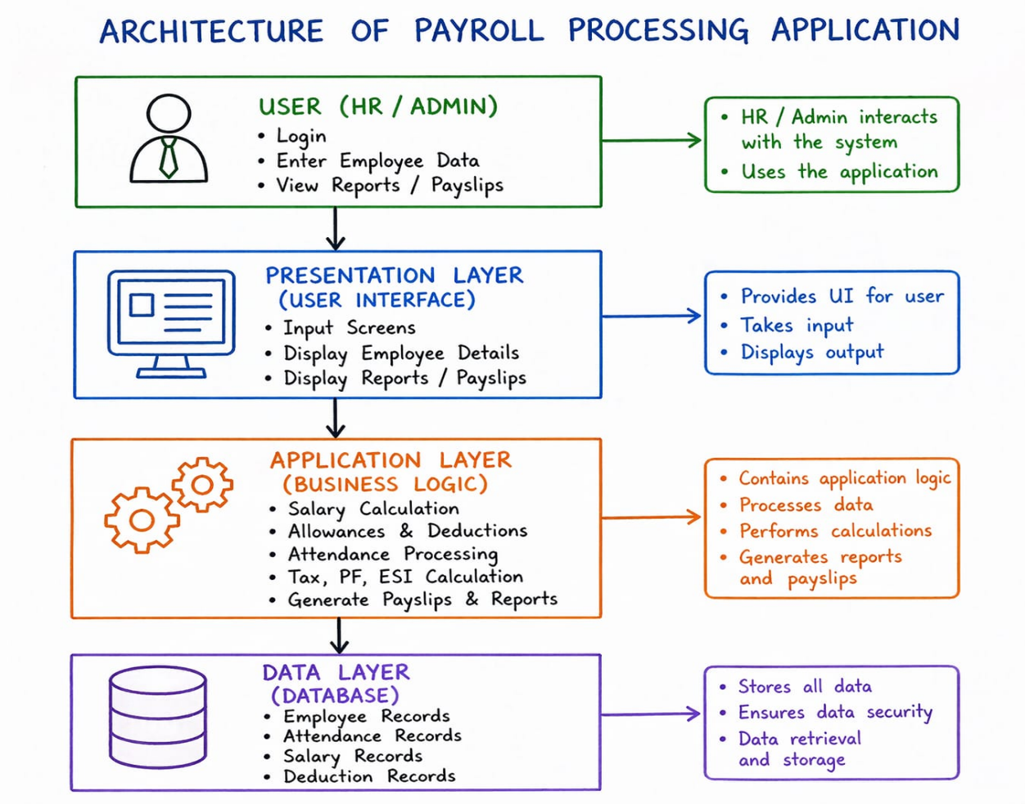

2. SOFTWARE REQUIREMENTS SPECIFICATION (SRS)
2.1 INTRODUCTION TO SRS
- Software Requirements Specification (SRS) is a detailed document that explains the complete working of a software system.
- It clearly defines what the system should do and how it should behave in different situations.
- SRS acts as a communication bridge between users and developers, helping both understand the system requirements properly.
- It includes different types of requirements such as functional, non-functional, and domain requirements.
- A well-prepared SRS helps in reducing development errors, saving time, and improving software quality.

2.2 USER REQUIREMENTS
User requirements describe what different users expect from the system.
2.2.1 Admin (HR) Requirements
- The admin should be able to login securely using a username and password.
- The system must allow the admin to add new employees with complete details such as ID, name, department, and salary.
- The admin should be able to update or delete employee records whenever required.
- The system should allow the admin to enter attendance details for employees regularly.
- The admin must be able to define salary structure, including basic salary and allowances.
- The system should provide an option to process payroll monthly for all employees.
- The admin should be able to generate reports such as monthly salary reports and employee details.
2.2.2 Employee Requirements
- Employees should be able to login securely into the system.
- The system should allow employees to view their salary details clearly.
- Employees must be able to download or print their payslip for reference.
- Employees should not have permission to modify any payroll data, ensuring data security.
2.3 PERFORMANCE REQUIREMENTS
- The system should process payroll for all employees quickly (within a few seconds) to ensure timely salary generation.
- The application should provide fast response time for operations like login, data entry, salary calculation, and report generation, usually within 1–2 seconds.
- The system should support multiple users at the same time without affecting performance.
- It should handle large amounts of employee and salary data efficiently without slowing down.
- Database operations such as storing and retrieving data should be fast and optimized.
- The system should maintain stable performance during peak times, especially during monthly payroll processing.
- The application should generate payslips and reports quickly without delays.
- The system should use hardware resources efficiently and should not crash under heavy load.

2.4 FUNCTIONAL REQUIREMENTS
User Authentication
- The system should provide a secure login feature for both admin and employees using username and password.
- It should validate user credentials before allowing access to the system.
- The system should allow users to logout safely after completing their work.
Employee Management
- The system should allow adding new employee details such as ID, name, department, designation, and contact details.
- It should allow updating employee information whenever required.
- The system should support deleting employee records when an employee leaves the organization.
- It should display a complete list of employees for easy management and searching.
Attendance Management
- The system should allow recording of daily attendance (present/absent).
- It should calculate the total working days and leaves for each employee.
- The system should support tracking of paid leaves and unpaid leaves.
Salary Structure Management
- The system should allow defining salary components such as basic salary, HRA, DA, and other allowances.
- It should allow modifying salary structure based on company policies.
- The system should support different salary structures for different employees or departments.

Salary Calculation
- The system should calculate gross salary by adding all earnings (basic + allowances).
- It should apply deductions such as tax, PF, and other deductions.
- The system should calculate net salary after deductions accurately.
Payroll Processing
- The system should process payroll monthly for all employees.
- It should store payroll details for each month in the database.
- The system should maintain salary history for future reference.
Payslip Generation
- The system should generate detailed payslips for each employee.
- Payslip should include earnings, deductions, and net salary.
- The system should allow users to download or print payslips.
Report Generation
- The system should generate monthly payroll reports.
- It should generate department-wise and employee-wise reports.
- Reports should be easy to understand and printable.
Search and Filter
- The system should allow searching employees by name, ID, or department.
- It should provide filters to view specific payroll records quickly.
Data Backup and Recovery
- The system should provide data backup options to prevent data loss.
- It should allow recovery of data in case of system failure

2.5 NON-FUNCTIONAL REQUIREMENTS
Security
- The system should provide secure authentication using username and password to prevent unauthorized access.
- Only authorized users (admin and employees) should be allowed to access payroll data.
- Sensitive information such as salary details must be protected and kept confidential.
- The system should ensure data safety by preventing unauthorized modifications.
Usability
- The application should have a simple and user-friendly interface so that users can easily understand and operate it.
- The system should provide clear navigation between modules like employee management, payroll, and reports.
- Even users with basic computer knowledge should be able to use the system without difficulty.
Reliability
- The system should provide accurate and consistent results, especially in salary calculations.
- It should work without failures during important operations like payroll processing.
- The system should ensure data integrity, meaning stored data should not be corrupted or lost.
Performance
- The system should respond quickly to user actions such as login, data entry, and report generation.
- Payroll processing should be completed within a short time without delays.
- The system should handle multiple users and large data efficiently.
Scalability
- The system should be able to handle an increasing number of employees without affecting performance.
- It should support future expansion, such as adding more features or users.
Maintainability
- The system should be easy to maintain and update when changes are required.
- New features or modifications should be added without affecting existing functions.
- Code should be simple and well-structured for easy debugging.
Availability
- The system should be available for use whenever required, especially during payroll processing time.
- Downtime should be minimal to avoid interruptions in work.
Portability
- The application should run on different systems such as Windows and Linux without major changes.
- It should be easy to install and use on different machines.
2.6 DOMAIN REQUIREMENTS
Salary Structure Rules
- The system should follow the organization’s salary structure, which includes components like basic salary, allowances, and benefits.
- Allowances such as HRA, DA, and other incentives must be included properly while calculating the gross salary.
- The system should allow flexibility to modify salary components based on company policies.
Deduction Rules
- The system should apply mandatory deductions such as Provident Fund (PF), Professional Tax, and Income Tax.
- PF should be calculated as a fixed percentage of basic salary (for example, 12%).
- Tax deductions should follow government rules and salary slabs.
- The system should allow updating deduction rules whenever policies change.
Attendance-Based Calculation
- The system should calculate salary based on number of working days and attendance.
- If an employee takes leave or is absent, the system should deduct salary accordingly.
- Paid leaves should not affect salary, while unpaid leaves should reduce salary.
Overtime and Bonus
- The system should support overtime calculation, where employees are paid extra for additional working hours.
- Overtime rates should be defined as per company policy.
- The system should include bonuses and incentives, which may be given based on performance or special occasions.
Payroll Cycle
- The system should process salaries on a monthly basis, as per standard payroll practices.
- It should maintain a proper schedule for salary calculation and payment.
Salary Records and History
- The system should maintain past salary records of employees.
- These records should be useful for report generation, auditing, and analysis.
Compliance with Rules
- The system should follow all legal and organizational policies related to payroll.
- It should ensure that salary calculations are done accurately and according to rules.
Flexibility of Rules
- The system should allow easy modification of salary rules, tax rates, and deduction percentages.
- Changes in policies should be updated without affecting existing data.

2.7 HARDWARE REQUIREMENTS
- The system requires a computer or laptop to run the payroll application. This device is used by the admin and employees to access the system and perform operations like data entry and payroll processing.
- A minimum of 4GB RAM is required to ensure smooth execution of the application. Higher RAM (such as 8GB) is recommended for better performance when handling large amounts of employee and payroll data.
- The system should have a processor like Intel i3 or above (or equivalent) to perform calculations and database operations efficiently without delays.
- A hard disk with sufficient storage capacity (at least 500GB) is needed to store employee details, attendance records, payroll data, and generated reports. Using an SSD can improve speed and performance.
- A monitor/display unit is required to view the application interface, reports, and payslips clearly.
- Input devices such as a keyboard and mouse are necessary for entering data and interacting with the system.
- A printer (optional) can be connected to print payslips and payroll reports when required by the organization.
- The system should have a stable power supply to ensure uninterrupted operation and to prevent data loss during payroll processing.
2.8 SOFTWARE REQUIREMENTS
- system should run on an Operating System such as Windows or Linux, which provides the basic environment for executing the application. The choice of OS should support the selected programming language and tools.
- The application can be developed using programming languages like Python, Java, or C#, which are suitable for building desktop or web-based payroll systems. These languages provide good support for database connectivity and user interface design.
- A Database The Management System (DBMS) such as MySQL or SQL Server is required to store and manage all data related to employees, attendance, salary details, and payroll records. The database should support efficient data storage and retrieval.
- Development tools such as Visual Studio Code, Eclipse, or NetBeans should be used for writing, editing, and testing the program code. These tools provide features like debugging and code management.
- If the system is developed as a web application, it requires a web browser such as Google Chrome or Microsoft Edge to access the user interface.
- For web-based development, a local server environment such as XAMPP or WAMP may be required to run backend services and connect the application with the database.
- The system may use frameworks or libraries depending on the programming language, such as Django or Flask (Python) or Spring (Java), to simplify development and improve performance.
- The application should include security-related software features, such as authentication modules, to ensure that only authorized users can access the system.
- Proper database drivers and connectors should be installed to enable communication between the application and the database.
MODULES
Employee Information/Master Module:
Stores personal information, tax IDs, bank details, salary structure, and employment history.
Attendance & Leave Management Module:
Tracks employee attendance, working days, shifts, overtime, and leaves, integrating directly to calculate payable days
Salary Structure & Components Module:
Defines allowances, bonuses, and deductions (fixed or variable) for different employee groups.
Payroll Calculation Engine:
Automates net pay calculation, factoring in gross salary, taxes, deductions, and arrears.
Tax & Compliance Module:
Handles statutory deductions, such as income tax, Provident Fund (PF), and social security, ensuring compliance with local regulations.
Loan & Advances Management Module:
Manages employee loans, advances, and recovery schedules.
Disbursement & Banking Module:
Generates bank transfer files (salary sheets), calculates net payments, and supports direct deposit.
Employee Self-Service (ESS) Portal:
Allows employees to view pay stubs, apply for leaves, and view tax declarations.
Reporting & Analytics Module:
Generates payroll registers, tax reports, and cost analysis dashboards for management.
Accounting Integration Module:
Syncs payroll data with accounting or ERP software to automatically create journal entries.

